**Ideas for Presenters**

Please note: If you need any specific tools for your presentation (projector, table, electricity, etc.), make sure the organizers are aware prior to the day of the event. For additional resources to help spark presentation ideas, explore the HirePaths website.

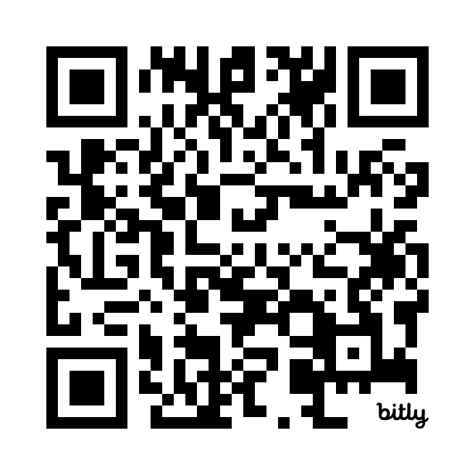**100+ Activities for Kids Lesson Plans**

**What to Incorporate into Your Career Hunt Session**

The following activities could be used for any industry.

* Talk about what your company does.
* Talk about what you do in your job and share some of the other jobs in your industry that kids might find interesting.
* Share fun facts and trivia about your industry or job.
* Create and handout a BINGO card revolving around your industry or job, then ask kids to cross out the terms they hear you say as you present. Consider offering a small prize to winners.
* Bring clothes used in your industry for kids to play dress-up.
* Assign the kids different roles and work through a scenario specific to your job.
* Consider bringing items for “Show and Tell:” Project or show photos of items and explain how each one helps you do your job, why it’s important, how it’s used, etc. Suggestions of items to bring include:
  + Tools you use
  + Things you wear
  + Items in your office
  + What you drive
  + A special piece of equipment
  + Computer software
* Bring videos or pictures of work being done at your company (or of you doing your job) and let students ask questions about what they see.

**Industry-specific ideas**

**Aerospace & Aviation**

* Movement-based activity: Tell kids to pretend to be planes, then act as an air traffic controller. This red rover-esque game will help kids understand airport flows.
* Facilitate a paper airplane design contest.
* Bring a model plane and explain what the different parts are called.

**Ag & Animal Health**

* Bring an animal (stuffed or live) and talk about how it needs to be cared for.
* Bring a product made from animals and talk about what goes into making that product ready for human use or consumption.
* Virtually introduce kids to an animal you work with that’s back at your office or farm.
* Bring samples of real crops to identify.
* Bring seeds and ask kids what crop they think the seeds will grow into.
* Show photos of equipment used in farming (tractors, planters, sprayers, combines with different heads, balers, etc.) and ask students to guess or tell how it’s used.

**Business & Administration**

* Have the kids practice answering the phone.
* Show/teach kids how to make change correctly.
* Fake interview: Ask for a volunteer and hold a mock interview.
* Give the kids a scenario for a new business or product and have them brainstorm possible names for it.
* Create a target audience to market your new, fake business or product to.
* Task the kids with creating a logo for a new, fake business.
* Discuss all the things that go into operating a business. (Consider making a BINGO card — see above — to help them stay focused on the content you’re introducing!)

**Construction**

* Ask kids about their experience with construction:
  + How many of you have seen the orange safety cones?
  + How many of you have driven on a road?
  + Do you recognize this business/building/road? (Show pictures of projects your company has built.)
* Discuss different projects, their challenges, etc.
  + Example: What do you think it takes to fill a pothole?
* Facilitate the marshmallow and toothpick tower activity. You can find a video about how to do this on YouTube: <https://www.youtube.com/watch?v=zrnR2y2Bzl4&t=2s>
* See who can build the biggest structure using LEGOs or other tools.
* Ask kids what they know about plumbing:
  + What happens when you use a sink?
  + Where does the water come from and where does it go?
  + What happens when you flush the toilet?
  + What might go wrong to get in the way of the water flowing correctly?
* Have kids design their own ____ (draw a house, draw a building, draw a road, etc.) then talk about what steps must happen to go from a design to construction in your industry.

**Culinary & Food Service**

* Bring ingredients to make something.
* Bring unusual ingredients for kids to smell or taste.
* Decorate cookies.
* Discuss the importance of math, like serving sizes, fractions, etc.
  + Example: You have 10 people, the meal is made for 2, how do you divide it up equally? Or make more servings?
* Use flour, sugar and water to teach kids about measurements (how many tablespoons in a cup, etc.).
* Ask kids about food:
  + Where does your food come from?
  + How do we get ingredients from around the world?
  + What’s the importance of locally owned/sourced?
* Discuss flavor theories (like salt, fat, acid, heat).
* Discuss flavor pairings.
* Show kids how to set a table.
* Explain what certain knives, forks, spoons, etc. are used for.
* Ask kids to identify unusual fruits or vegetables.

**Energy**

* Give an example of solar energy.
* Make batteries out of a potato.
* Discuss friction — if you rub your hands together, you create energy.
* Bring a balloon and discuss static electricity.
* Discuss magnets and their pulls; show examples.
* Discuss wind energy — bring a pinwheel.
* Play the telephone game (telephone wiring, Wi-Fi, etc.).
* Compare and contrast the different types of energy.
* Movement-based activity: Make the kids into circuits, connecting from Point A to Point B by holding hands.

**Manufacturing**

* Bring a robot and describe or demonstrate what it does.
* Form an assembly line with the kids to do a simple activity (like fill a large bucket through individual cups of water).
* Discuss the different kinds of assembly lines.
* Work together in an assembly to create something.
* Discuss workplace flow, how different stations come together to build one thing.
* Ask kids about production:
  + What do you think it takes to make ____?
  + What raw materials would you need to make ____?
* Inspection activity: How are two products different from each other?
* Inspection activity: Bring two photos, ask the kids to find the differences.
* Sorting game: Sort items in different ways (by height, size, color, etc.).
* 3D printing ideas:
  + Bring something that’s been 3D printed
  + Bring a 3D printer and have it running in background so kids can watch the progress
* Define and discuss advanced manufacturing and how it’s transforming your operations.

**Medical**

* Show kids how to take their own pulse.
* Show kids how to use a stethoscope.
* Show kids how to take blood pressure.
* Give kids hands-on experience with a stethoscope by having them listen to each other’s hearts.
* Give a tour of the body, explaining where your kidneys, lungs, etc. are.
* Bring in a skeleton or model.
* Bring in CPR dummies.
* Talk about jobs in medicine other than doctors or nurses (imaging, IT, physical and occupational therapy, phlebotomy, etc.)
* Demonstrate or teach kids how to do stitches using sewing needles and fruit.
* Discuss the best way to clean scratches or other minor injuries.
* Talk about what people need to do to stay healthy (eat right, exercise, get regular checkups, avoid smoking, etc.).
* Ask kids about treatments:
  + Why do you put ice on bruises?
  + Is heat or cold better for certain injuries?

**Public Service**

* Ask kids about teachers:
  + What kinds of things did your favorite teacher do?
  + What does your teacher do that you may not think about?
* Ask kids about emergencies:
  + Have you ever called 911?
  + What’s the appropriate way to call 911?
* Give a virtual truck tour.
* Give a virtual police car tour.
* Demonstrate how to do CPR on a dummy.
* Book-sorting activity — What’s the Dewey Decimal System?
* Define public service.
* Discuss the role of Parks and Rec in a community.
* Discuss all the different jobs needed to keep a city running.

**Service**

* Give a hair demonstration on a mannequin.
* Give a nail demonstration.
* Have kids paint on training nails.
* Ask kids about pest control:
  + What areas need pest control?
  + What pests do we have in Kansas?
* Talk about car repair:
  + The most common repair
  + Why cars need maintenance
* Fill up a tire with air, showing how to use an air pressure tool.
* Show how to pot a plant for landscaping.
* Have kids design their own lawn/yard.
* Perform a demonstration with a baby doll.
* Show how to perform CPR on a baby.
* Show how to properly hold a baby.
* Solve logic puzzles as a group or individually.
* Ask kids what they know about buying and selling real estate:
  + What are things realtors do?
  + What are the steps to buying a house?
  + What do you need for an open house?
* Have kids design their dream house.
* Have kids try out what it is like to serve customers as a flight attendant or waiter.
* Ask kids about their experience with hotels:
  + Have you ever stayed at a hotel?
  + What does a hotel clerk do?
  + What are the different jobs in a hotel?
* Have kids design their own jewelry on paper or make a bracelet or necklace with household items like buttons or macaroni.
* Learn to do retail activities:
  + Answer the phone
  + Make change
  + Welcome someone who has entered a store

**Technology**

* Show basic coding.
* Explore ChatGPT.
* Brainstorm using ChatGPT.
* Ask kids what they know about technology and then teach them about topics like:
  + How do cell phones work?
  + How does Wi-Fi work?
  + What will technology bring in the future?
* Bring in old equipment (computers, servers, phones, tablets) and tools and let kids take it apart and look inside. Explain what they are seeing.
* Ask kids about gaming:
  + What steps are needed to make a video game?
  + What makes a good video game?
  + What’s your favorite app or video game and why?
* Ask kids about social media ads:
  + Do you use social media?
  + Have you seen ads when you’re using social media?
  + Do you know why social media platforms have ads?
  + What makes an effective digital ad?
* Have kids help you design a website homepage.
* Design a logo together.
* Perform a live demo using CAD.
* Demonstrate using a robot — even a Roomba could work!
* Make a tornado with a liter bottle.
* Ask kids about meteorology:
  + How does radar technology work?
  + How is it used?

**Transportation**

* Ask kids about transportation:
  + How many types of transportation do you think it might take to ship something from China to your home in the U.S.?
  + How many types of transportation can you think of?
  + How many modes of transport have you taken?
* Bring toy cars, buses, etc., and talk about the parts of a vehicle.
* Bring a VR simulator and let a few volunteers try it out.
* Perform a drone demo or show drone footage.
* Discuss the many uses for drones.
* Talk about the ins and outs of shipping.
* Show how to check tire pressure.
* Explain what different dashboard lights mean in a car.
* Bring in models or pictures of machines at work.
* Show a common problem on a machine and how someone would go about fixing it.
* Discuss what different street signs mean.